ClinicalKey Mobile App

ClinicalKey is a clinical search engine that gives access to a comprehensive collection of medical and surgical content. All Seha staff has free access to ClinicalKey through Seha’s institutional subscription making your user experience on the go as valuable, easy and fast.

Steps to download the app:
- Download ClinicalKey app on your smart phone form apple store / Google’s Play Store
- Login by using your OpenAthens credentials
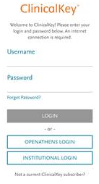
- When logging in for the first time, choose “Global” edition (the app will remember your settings for future use)
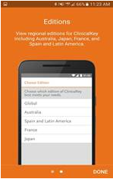
- Language setting:
- ClinicalKey app is available in multiple languages. Select “English”.
