How to download MICROMEDEX Mobile Apps

- Login to “Micromedex” in Seha elibrary http://elibrary.seha.ae. You will land at the following page:
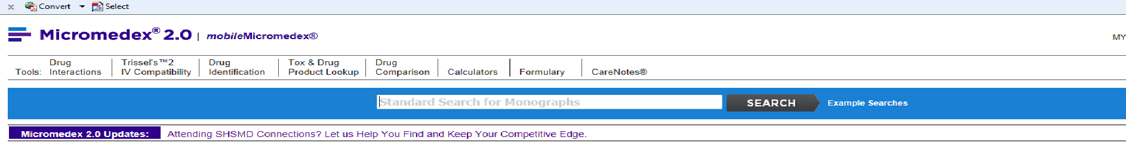

- Click “mobileMicromedex”
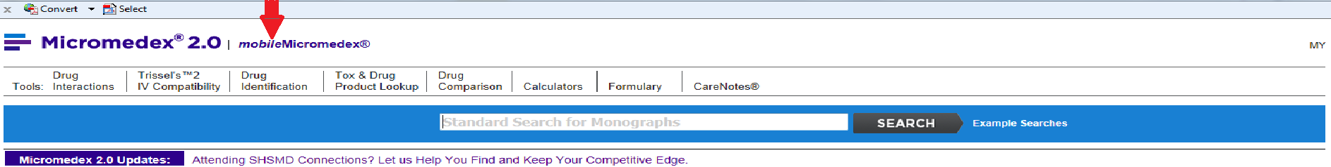

- You get the following step by step instructions to download:
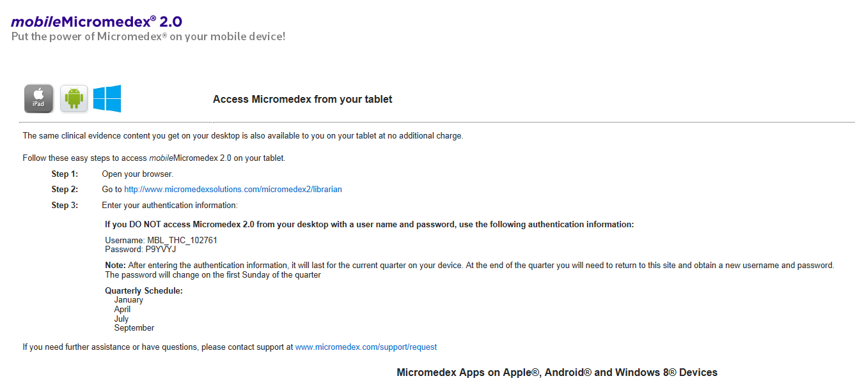

- Follow all the above steps to download the following 3 Micromedex offline applications on Apple, Android, and Windows 8 smart phones & tablets by going to App Store or Google Play :
  - Micromedex Drug Reference
  - Micromedex Drug Interactions
  - Micromedex IV Compatibility

- Use the passwords mentioned in step number 4 to complete the downloading process and also to update the evidence based databases every quarterly.

